1921 Kildare Senior Hurling Championship –
Celbridge Centenary Win Remembered

Ciarán O’Donovan

Fr Fogarty blew the final whistle shortly after 4pm, and with that, the Celbridge supporters within the large crowd in attendance at the Dominican College grounds in Newbridge that late April Sunday afternoon in 1923, cheered their victorious hurlers. Draped in white and green, Celbridge had just won the club’s first Kildare Senior Hurling Championship with victory over the home team, St Conleiths by 4-2 to 0-1. It was of course historic times in more ways than one, with the backdrop to the match being the War of Independence and the Civil War which had intervened to delay the conclusion of this 1921 championship by two years. In fact, the Civil War was not to formally end for another month. The match was played on Sunday 29th April 1923, just a single day before Frank Aiken (IRA Chief Of Staff), who had only recently assumed the role after the death of Liam Lynch on the 10th April, declared a ceasefire on behalf of the Anti-Treaty forces. The Civil War formally ended on the 24th May when Aiken gave the order for Anti-Treaty fighters to “dump their arms” and return home. This was the immediate context of Celbridge’s first Kildare SHC victory.

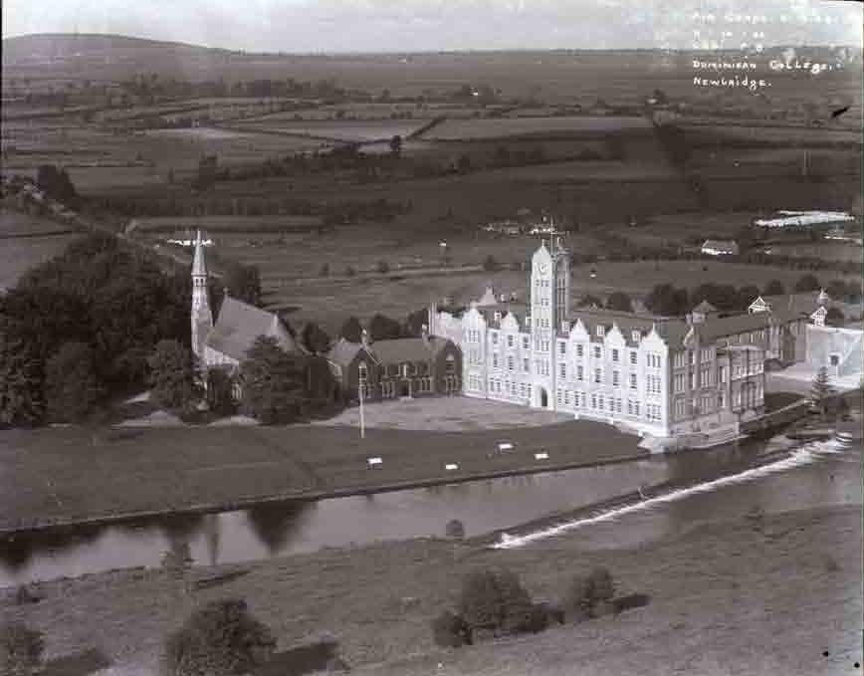

Dominican College, Newbridge - circa 1932

The Hurling Scene
Hurling in Kildare was not high profile by any means at the time, having been eclipsed by the Kildare footballers’ success and their participation in multiple All-Ireland finals – the 1903 home final, 1905 (winners), and 1919 (winners). In particular, the three match series in the 1903 All-Ireland home final (played in 1905), which was eventually lost to Kerry, caught the Kildare public’s imagination. There were, however, high profile hurling matches played in the county, including the 1908 All-Ireland Hurling final replay (played in 1909) when Tipperary defeated Dublin at the newly built Geraldine Park, Athy. The same venue had also previously hosted the 1907 Leinster Hurling final when Kilkenny bested Dublin.
The political situation at the time impacted upon all sporting and GAA activities across the country, and the fact that the 1921 Kildare SHC final was not played until 1923 was not unusual. The 1921 All-Ireland hurling final was also played in 1923, with Limerick beating Dublin on 4th March. Incidentally, this was the first occasion that the Liam McCarthy Cup was presented to the winning captain – Bob McConkey from Limerick. In fact 1923 saw two All-Ireland hurling finals being played within six months of each other, as the 1922 decider in which Kilkenny defeated Tipperary was played on the 9th September. Even before the political turmoil of the period it was commonplace for county and All-Ireland championship finals to be played in subsequent years.

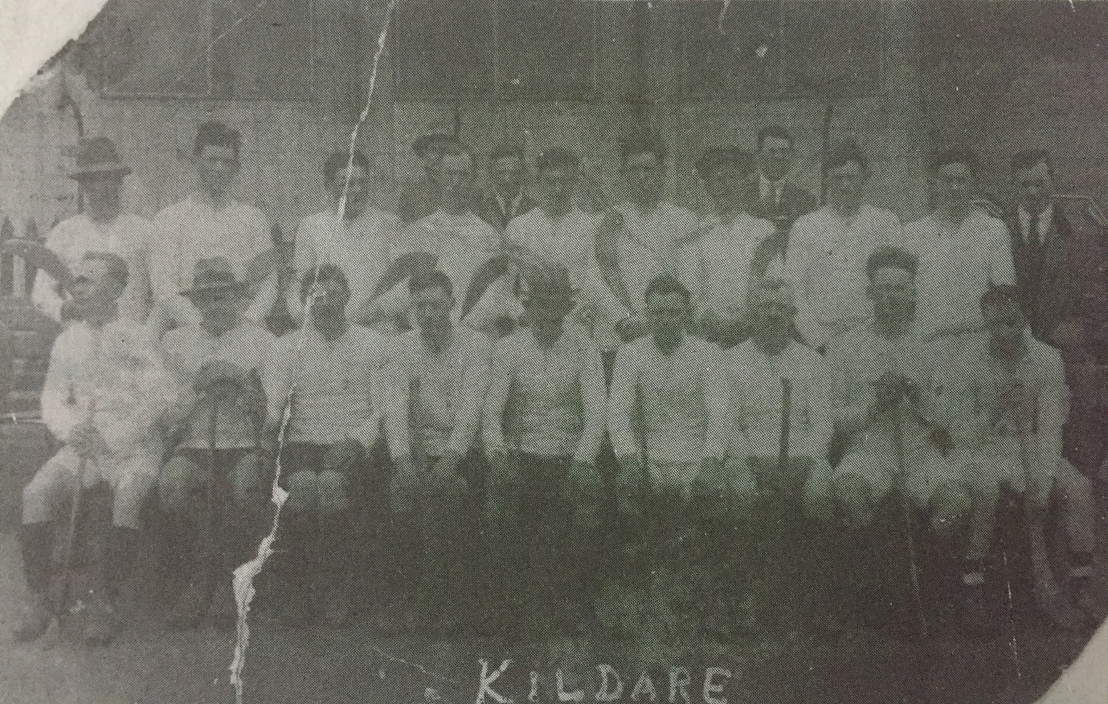

Kildare hurling team from 1930’s – a good example of the style of hurley and kit of the era, including hats and cap!

Clane were the Kildare hurling kingpins of the period. Their 16 titles won between 1903 and 1922 still leads the Kildare SHC roll of honour. They played in 17 finals, losing just once (in 1913 to Maynooth on objection); this included winning a 9-in-a-row between 1903 and 1911, and a 6-in-a-row between 1914 and 1919. The championships of 1912 and 1920 were unfinished so it meant that between 1903 and 1922 Clane played in every single SHC final apart from the 1921 championship decider – the final contested by Celbridge and St Conleiths. These two clubs, were probably Clane’s closest competition at the time.

St. Conleith’s original application to be the third Newbridge GAA club was rejected in January 1891 because its membership was confined to Catholics. The club successfully affiliated in 1901. They proceeded to win the Kildare Senior Hurling championship in 1901 and 1902, and the Junior championship of 1936 and 1938. They lost the finals in 1910, 1914, 1915, 1917, all to Clane. The St Conleiths team was a reincarnation of St Thomas College (a.k.a. Newbridge College) who were the 1900 Kildare SHC champions. Many of the senior players in the team at the time were teachers and ground-staff in the College, hence the team became known as St.Conleiths.

The Newbridge side was attempting to win the 1921 hurling and football championship double, having already captured their one and only Kildare Senior Football championship title in controversial circumstances. Although they actually were defeated by Caragh 1-2 to 1-12, St Conleiths were awarded the title on objection because one of the Caragh players (a C. McCarthy) gave a false name as he was 'on the run' from National Army troops at the time. Winning matches by objection was a quite common occurrence at the time with many and colourful rationales being provided. One of the main reasons would often be the playing of ‘duds’ – unregistered players or players from outside the county – which was very frequent. A particularly good example of the variety of grounds presented was demonstrated in the objection lodged to the Kildare County Board by Celbridge following a close defeat to Maynooth in the 1913 hurling championship on 24th November:

“One, The Maynooth goal man could not be distinguished from spectators who were standing in goal with him with hurleys in their hands. Two, The referee did not award penalty pucks in accordance with the rules of the Association. Three, Celbridge goal man and full backs were interfered with by spectators, the referee on one occasion, having to stop the game and clear the goal. Four, The first and last goals awarded to Maynooth were illegal as on the first occasion the man who scored was inside the five yards square before the ball and in the case of the last goal there were four players inside the square before the ball came in”.

The objection was unsuccessful but it certainly demonstrated how eventful matches were at the time. Maynooth played Clane in the final of the 1913 championship and were ultimately awarded the title – by objection.
It would seem that walkovers were even more commonplace; the Kildare Observer reported on 31st January 1920 that neither hurling championship match scheduled for Naas the previous Sunday actually went ahead as Naas were unable to field a team against Clane, and although Celbridge travelled to Naas, the Kildare team “failed to put in an appearance and Celbridge gained a bloodless victory”. Indeed, the very first Kildare championship in 1888 was awarded to Monasterevan without a single ball being pucked; they received a walkover in the championship’s only match – the final - when their opponents Maynooth were too tired from playing in a football semi-final that same afternoon which went to extra time. Maynooth, in turn, were awarded the 1896 championship title when they got a walkover from Moorefield. As Eoghan Corry said in his Kildare GAA – A Centenary History “throughout the era of Clane dominance the championship mainly consisted of a series of walkovers”.

Celbridge lost two SHC finals to Clane in the 1906 and 1919 championships, while also losing to Maynooth in the 1924 championship decider, played in 1925. That would be the last Kildare SHC final that Celbridge would contest for 80 years until 2005 when the modern crop of Celbridge hurlers began their run of success in the grade.
The 1906 final score finished Clane 5-9 Celbridge 3-2. In the 1919 decider Celbridge were actually leading 2-0 to 0-0 at half time, but Clane fought back to win with the final score ending Clane 2-3 Celbridge 2-0; this was the nearest that any team had pushed Clane in their previous 14 final wins. It no doubt demonstrated the improvement within Celbridge hurling ranks and signaled the imminent success to come.
The 1920 championship was never concluded; in the 1921 championship Celbridge and Clane met at the semi-final stage with Celbridge surprising the reigning champions. Clane claimed they were missing a number of prominent players for the match, and with wounded pride they quickly rearranged a challenge game, taking one of their main players John Cribbin out of Celbridge hospital (previously Celbridge workhouse and now Colourtrend paint factory) to make up the team. Clane won the match and returned to win the 1922 championship; this would be the last of their 16 Kildare SHC titles – a major contributing factor to their decline was that the club suffered a split in 1922, probably related to the Civil War, which led to the establishment of Mainham hurling club.
As the 1920 championship was never completed it meant that the 1921 final was the second successive final for the Celbridge side, who would face a St Conleiths team that last competed in the 1917 decider.

The Gear
Both teams it is believed wore green and white in the 1921 final. St Conleiths wore a green jersey with white sash while Celbridge players donned the opposite – white jerseys with green sash. Many clubs at the time wore colours with either a sash or hoops. Celbridge hurling colours changed over the years to red and black and finally the current blue and white. St. Conleith’s eventually was subsumed into the current Sarsfields GAA club which of course still wears the green jersey with white sash.

The score in the 1921 final was 4-2 to 0-1; such a score was not unusual, as the lack of points in hurling matches in particular was common fare at the time due mainly to the ‘tools of the trade’ available to players.
In 1904 the official GAA rules set the minimum weight for the sliotar at 7 ounces (198.5 grams) - nearly double the prescribed weight today which mandates that sliotars must be between 110-120g (3.9-4.2oz). When adding in the fact that sliotars of the era would soak up water in wet weather and easily lose their shape, then it is safe to conclude, that a century ago the large, cumbersome horse-hair packed sliotars and smaller bas hurleys contributed to a much slower and less spectacular game played mostly on the ground; consequently most games were characterised by the scoring of relatively few points. Another contributing factor was that sliotars up to the late 1930’s were brown in colour, making them difficult to see in muddy conditions. By the late 1930’s sliotars had been reduced to approximately the size we know today, the white sliotar became the standard, and higher scoring became common. In addition of course, Mick Mackey the Limerick legend, introduced the idea of soloing the sliotar on the hurley which was revolutionary for the game in the 1930’s and contributed to a further increase in scores and also to the sport’s popularity amongst the public.
The quality of hurley was also a problem – Owen Murphy recounted to Eoghan Corry that he remembered using sally camáns and having problems getting an ash one made by a carpenter.

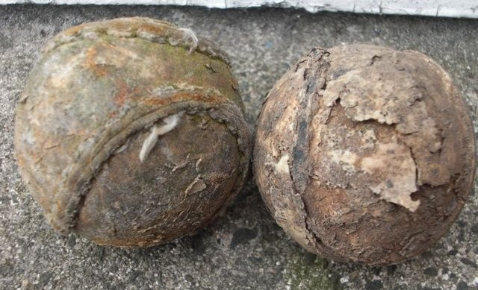

Example of sliotars used around the 1920s era

The Players and Officials
Both finalists could boast star players from multiple Kildare All-Ireland football winning teams.

Frank ‘Joyce’ Conlan was a double Kildare All-Ireland winner – corner forward in 1905 and left half forward in 1919 – and was the St Conleiths goalkeeper. He was also listed as playing for the Kildare hurlers against Meath in the Leinster JHC in 1915. His son Peter was the 1919 team mascot – at age 24 years he was one of four soldiers tragically killed in an explosion at Cullenstown Strand Co. Wexford in 1941 while attempting to make safe a sea mine which had washed ashore.
It is likely that other Kildare players from the 1919 All-Ireland winning team also formed part of the St Conleiths hurling squad – these would have included James ‘Jimmy’ Conlan (younger brother of Joyce), John Carey (brother-in-law of Jimmy and Joyce Conlan), and Peter Grady.

George Magan - right half forward in 1919 – was a core player for Celbridge. Born in Kingsfort, Co. Meath his family moved to Celbridge where his father worked as stud groom in Castletown estate. They lived in the ‘Roundy House’ beside the Castletown House gates in Celbridge. George variously played for Celbridge up to 1915, then switched allegiance to Maynooth, then Kilcock, before returning to the Celbridge fold at the turn of the decade in 1920. He was a great athlete winning All-Ireland cross country titles in 1920 and 1922 as well as representing Ireland on the cross-country international team for five seasons. George won seven National middle distance titles over 880 yards (half mile) and 1 mile between 1918 and 1922. He had numerous victories from 220 yards to ten miles, and in 1925 alone he won no fewer than 100 prizes, comprising races at 220, 300, 440 and 880 yards, 600 and 1,000 metres, one mile, two miles and three miles. George was a member of An Garda Siochana, and as such he also won the Police Championships of England and Ireland in the 400 yards and mile three years in a row. George has the distinction of being the first Protestant to win an All-Ireland medal. He subsequently converted to Catholicism in advance of marrying his wife Marcella Dunphy in 1935.
George played alongside his brother William Magan in the 1923 victory for Celbridge.

Albert O’Neill – substitute in 1919 - was born and raised in Celbridge; he lived at Union Lane and Big Lane. Known as ‘Little Albert’ due to his diminutive size, he emigrated to England and upon his return to Ireland moved to live in Kildare town and so played his football with Maddenstown and Kildare Round Towers. It is believed that Albert’s older brother Henry O’Neill was also a member of the Celbridge team in 1923.

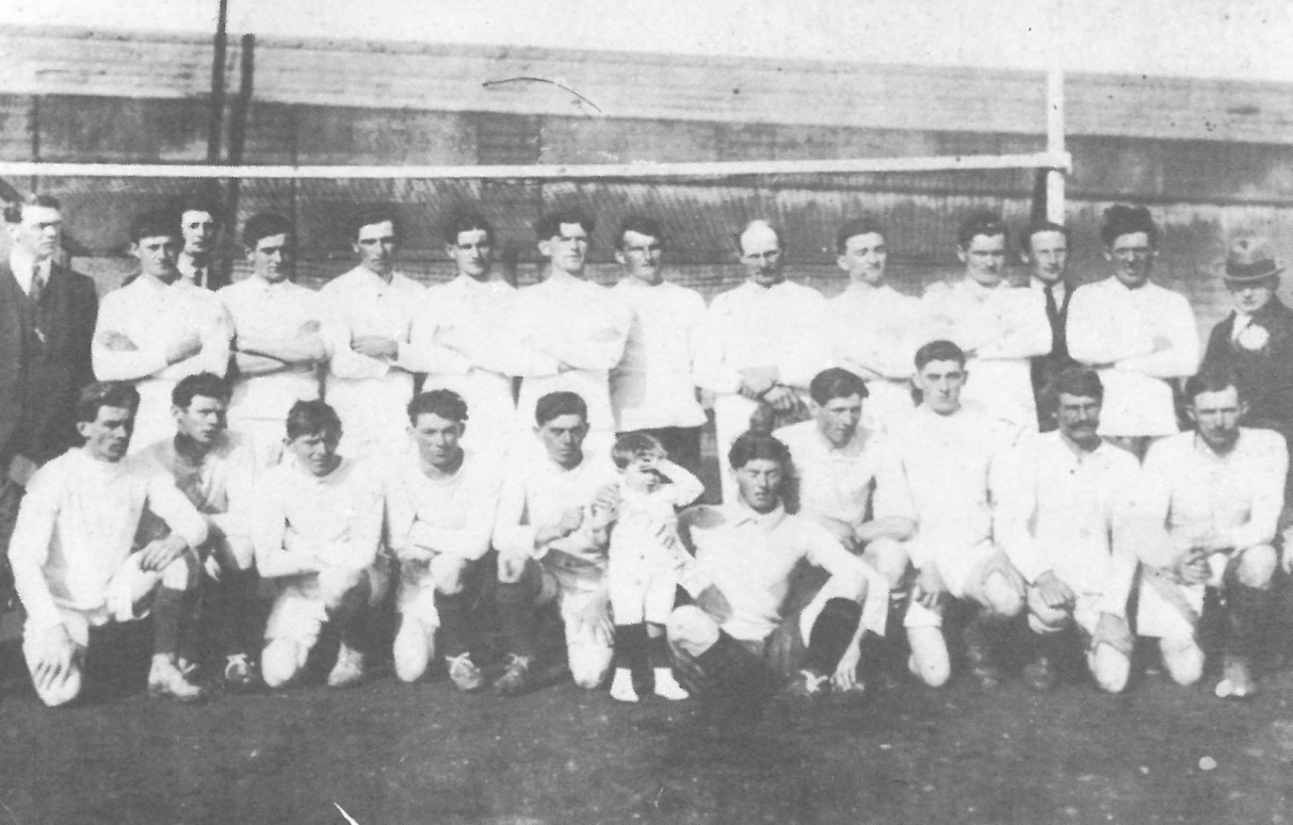

1919 Kildare All-Ireland Football champions. Mick Sammon – back row 2nd player on left; Jimmy Conlan – back row 4th player on left; Peter Grady – back row 1st player on right; John Carey – front row 3rd on left; Albert O’Neill – front row 5th on left; George Magan – front row 3rd on right; Frank ‘Joyce’ Conlan – front row 1st on right; Peter Conlan – front row centre, standing

Mick Sammon – midfielder for Kildare in 1919, and referee of the fateful ‘Bloody Sunday’ match on 21st November 1920 – was an administrator in Celbridge GAA at the time of the 1921 hurling championship final. Mick owned the Railway Hotel in Celbridge (now McNamees Abbey Lodge).

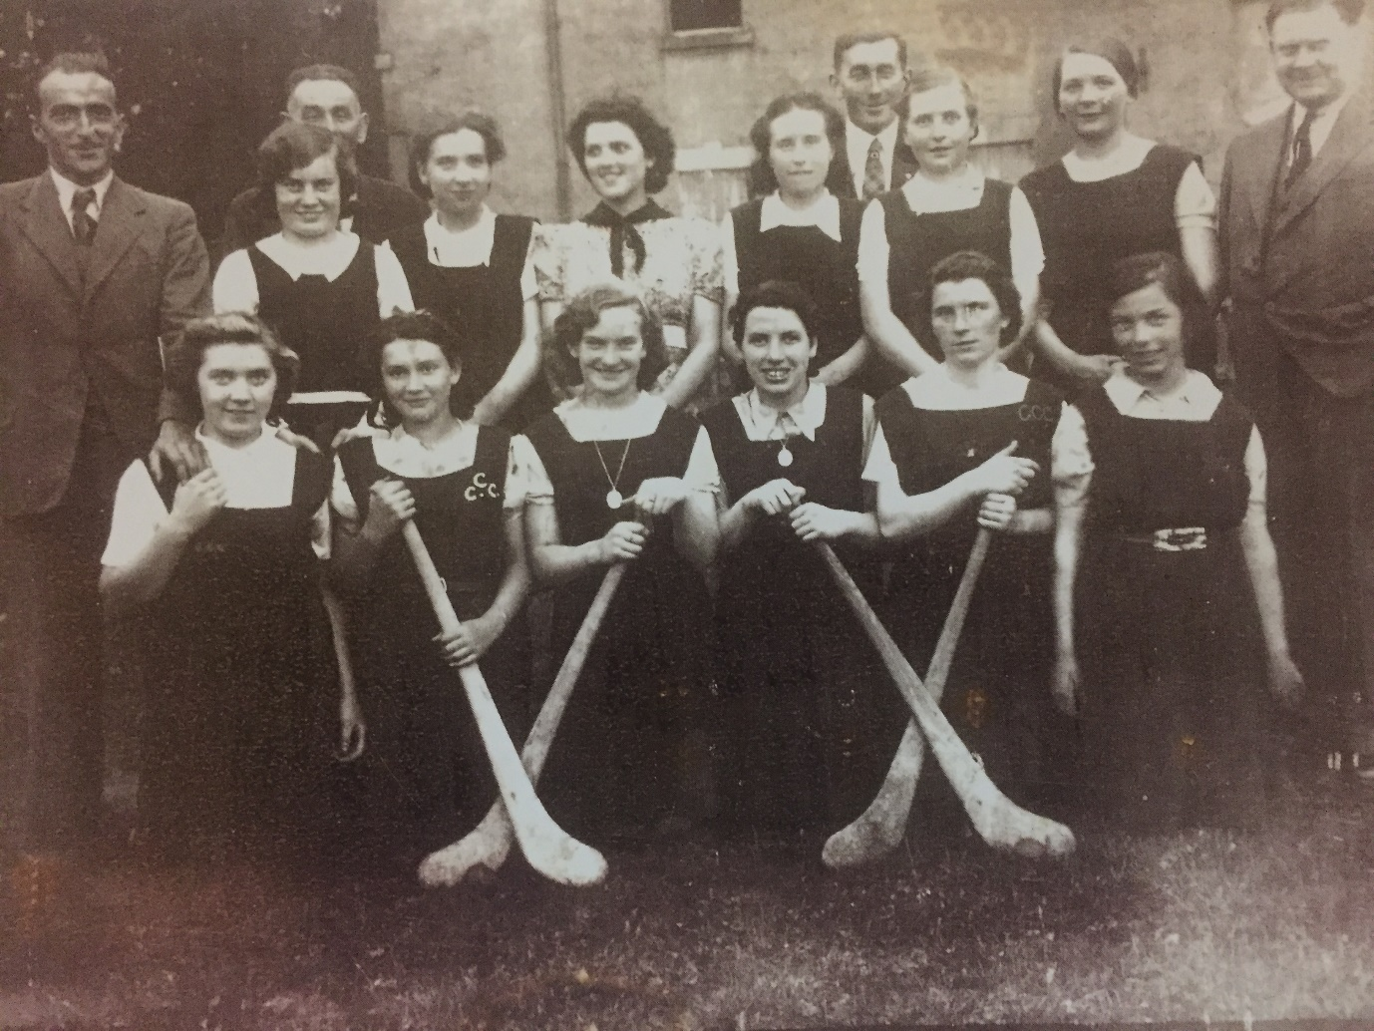

Mick Sammon back row, far left, with Celbridge Camogie team late 1930’s. His daughter Betty is in the middle back row with dress. Kate Masterson, daughter of Tommy, is in the front row, far left

At the time Celbridge boasted a number of Kildare county hurlers including Edward ‘Ned’ Mulligan, Patrick ‘Paddy’ Healy, and of course Owen ‘Skipper’ Murphy who was the Celbridge winning captain for the 1921 final. The Drogheda Independent named all three in the Kildare team due to play Dublin in Kilkenny on the 22nd June 1924, with Paddy Healy listed as the Kildare captain. Paddy went on to become a respected GAA referee in Kildare. He and Albert O’Neill were brothers-in-law.

Jim Fay and Albert O’Neill were on the Celbridge team that day in April 1923 – they also played hurling for Kildare, and of course in addition Albert was a star Kildare footballer. One month after the final they both lined out for Kildare on the 27th May in the Leinster Junior Hurling championship v Offaly, alongside their Celbridge team mates ‘Skipper’ Murphy, Ned Mulligan and George Magan; it was played just three days after the end of the Civil War.
Celbridge played Kildare Round Towers in the Leinster Leader Cup football final in July 1924, however Albert was by now playing for Round Towers, not Celbridge. ‘Unfortunately’ Albert gave a match winning performance that day scoring 1-1 of the Kildare Round Towers total of 1-6, beating Celbridge by 3 points.
Albert married Catherine Wilmot on 26th November 1927; tragically she died just 8 months later of tuberculosis. Albert never remarried. He died on 1st April 1980, and was buried with his wife at St. Conleth’s Cemetery, Kildare.

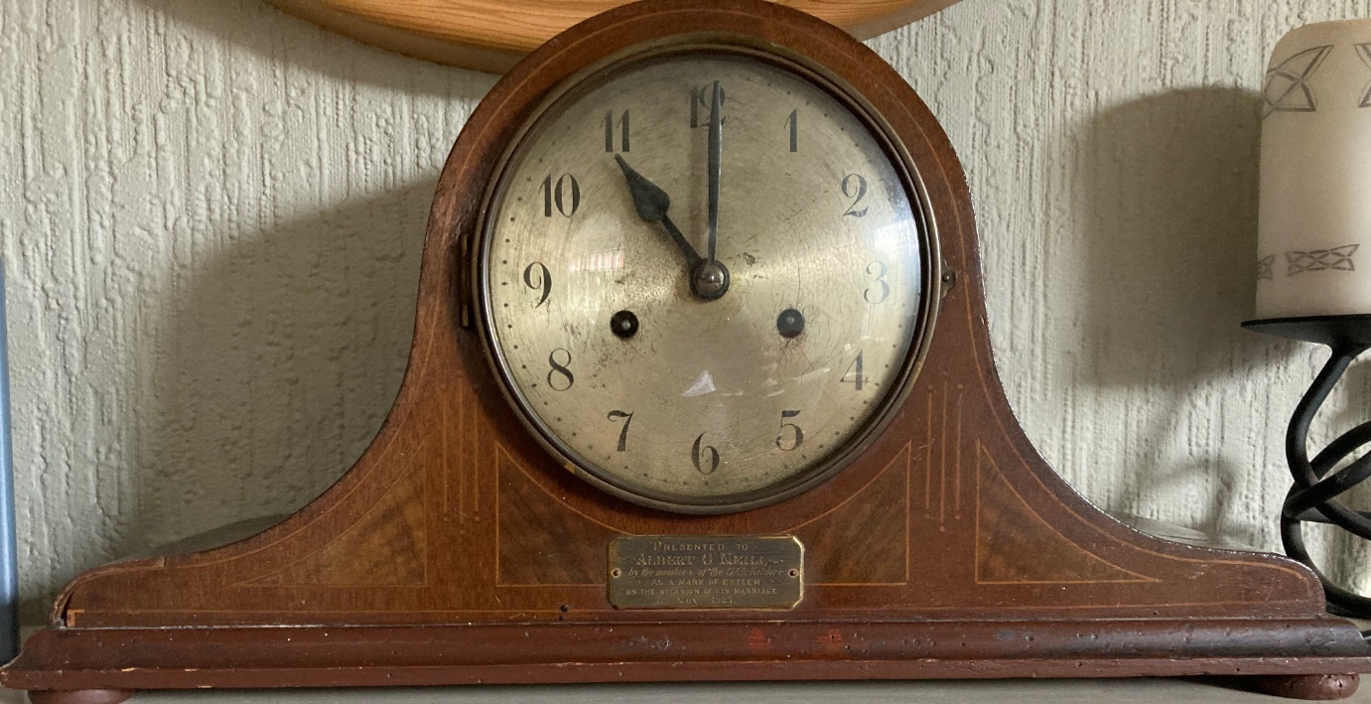

Clock presented to Albert O’Neill by Kildare GAA on the occasion of his marriage in November 1927

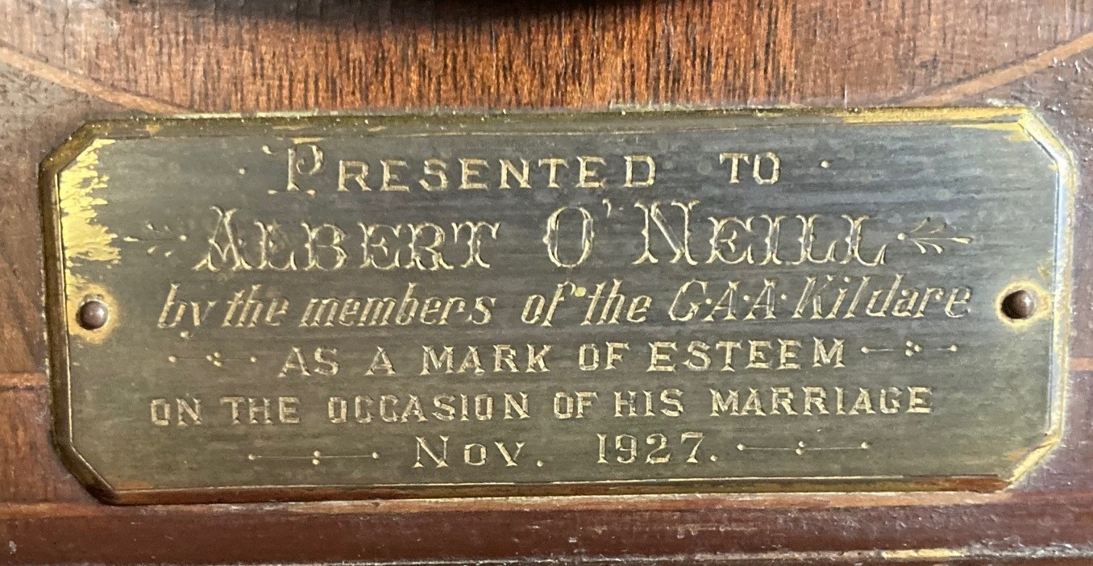

Clock inscription – both photos courtesy of Pat Murphy

Jim Fay was actually from Newtown, Maynooth, but as explained by his son Tommy, at the time “he decided to walk over to Celbridge to get a game of hurling”. Ironically, when Maynooth defeated Celbridge in the 1924 Kildare hurling final (played in 1925), Jim was on the Maynooth team which beat his 1923 Celbridge team mates. Therefore Jim won two Kildare SHC medals with two different clubs. Tommy also recalled his father telling him how he won the 1927 Kildare Minor Football title with Maynooth when he was 27 years old! The Maynooth manager saw that size of the Round Towers team taking to the pitch and decided to call upon Jim and a few other older lads to play in order to even things up.
It is a funny coincidence that Albert O’Neill and Jim Fay, team mates for Celbridge in the 1923 hurling win, both played for other clubs (Kildare Round Towers and Maynooth respectively) which beat Celbridge in football and hurling finals within the next two years.

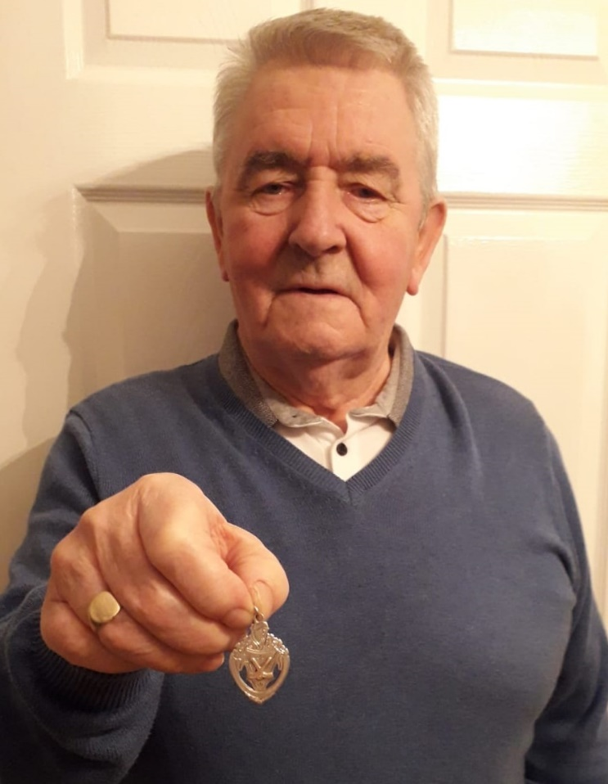

Tommy Fay holding his father Jim’s 1921 Kildare SHC medal

Owen ‘Skipper’ Murphy was the outstanding Celbridge player of his generation. A dual player, he played hurling and football (both senior and junior) for Kildare for over 20 years; his debut for the Kildare Junior footballers came in 1918 against Carlow when he scored 3 goals - all straight from ‘50s’! In conversation with Darragh McIntyrne he explained “That was common then because the full forward would go for the goal keeper, all you had to do was get the direction right”.
As well as captaining the Celbridge team to their 1921 SHC triumph, he was captain of the 1931 Kildare Junior footballers and also captained the club to victory in the 1936 Intermediate Football final when he scored 0-6 of the Celbridge total of 2-6. A larger than life character, his commitment to Gaelic games in Celbridge and Kildare was incredible; from his first senior match played as a 17 year old in 1915, he continued playing for more than three decades and was also an administrator – as County Board delegate he attended 63 consecutive annual County Board conventions. His lifelong commitment to the GAA was recognised when he won the Kildare GAA Hall Of Fame award in 1981.

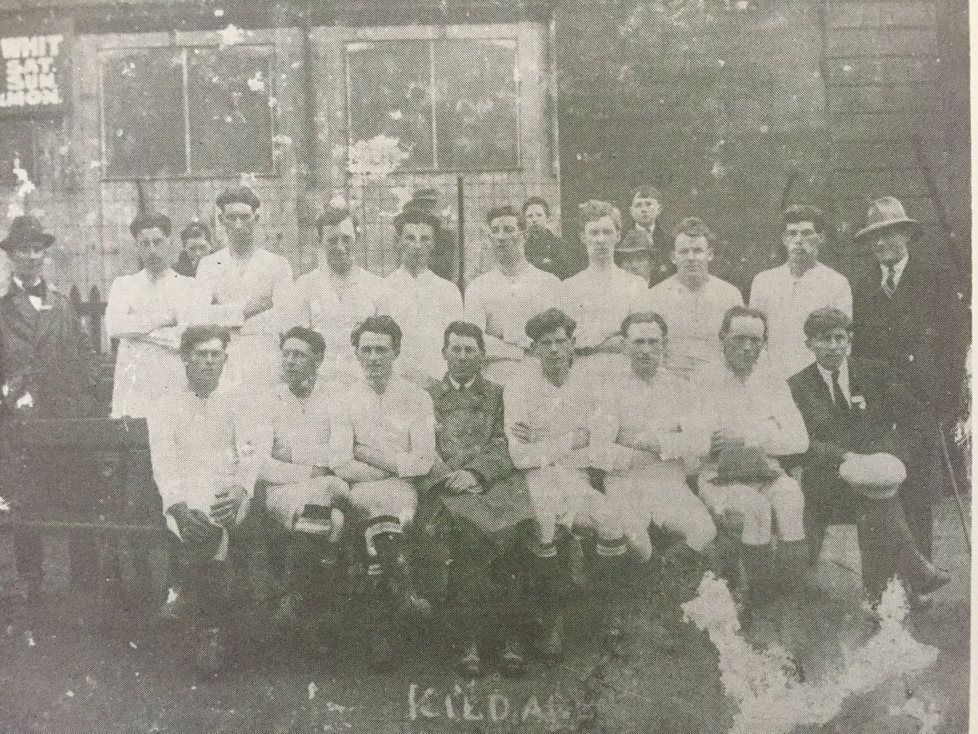

Owen ‘Skipper’ Murphy (captain) - front row, second left - with the 1931 Kildare Junior Football team

Barney Cullen, Tommy ‘Oxo’ Masterson, and James ‘Jim’ King all played in the 1921 Senior Hurling Championship final for Celbridge and indeed in the 1936 Intermediate Football victory. John Mulligan (brother of Ned) was also a member of the 1921 team. All four players had family connections back to Celbridge’s first appearance in the 1906 Kildare SHC final played on 20th January 1907. Players listed as having played against Clane that day included three Mulligans (Patrick Mulligan, James Mulligan and another P. Mulligan); there were also two Kings (E. King and J. King), along with two Cullens (C. Cullen and B. Cullen) and John Masterson.

Rev Fr. Albert John Fogarty O.P., B.A. was the referee for the final. He was a Dominican friar within the Dominican College Newbridge. Fr. Fogarty was born on 10th March 1892 in Galway; he resided in the Dominican College Newbridge from the time of his ordination, where he taught Irish, History and Geography, until 1930 when he was re-assigned to Sligo. Recognised as an expert geologist, it was said that his collection of native stones was the largest in the country outside of the National Museum. In 1933 he was reassigned to Tralee, after which he departed to work with the Dominican community in Australia in 1936, where he began a series of missions and retreats that brought him all over Australia and New Zealand. According to the 1953 edition of The Lanthorn - Year Book of the Dominican College, Eccles St Dublin, Fr Fogarty was known as “a most zealous, popular and beloved preacher” with a preaching style of his own. He died in Adelaide, Australia at age sixty on 30th April 1952.

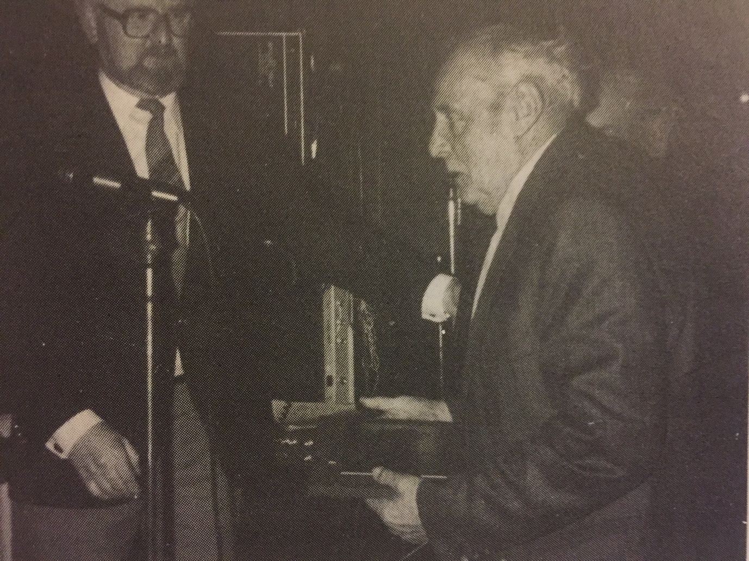

Owen ‘Skipper’ Murphy receiving his Hall of Fame Award in 1981

The Political Scene
It would be impossible to speak about GAA matters during the 1921-1923 period without touching upon the political situation at the time as both are intrinsically interlinked.
This was perfectly encapsulated at the 35th annual convention of the Kildare GAA County Board on 4th March 1922 at which Owen Murphy and George Magan attended as the Celbridge hurling delegates. The Chairman – Mr. T. Brophy – in a most eloquent address redolent of the best tradition of great Irish orations, spoke the following:

“The fleeting wheels of time have brought us once more around to another annual GAA convention. The early part of the year that has fled must have seen the time repeatedly referred to as the darkest hour before the dawn. As the closing stages of the year 1921 brought us the first glimpse of the bright dawn of the golden future and hopes for a new Ireland, the next few months, weeks, aye days, that lie before us are the all-important ones for us if this great new ray of hope is to be the success that all true Gaels and Irishmen wish it. I appeal to you today as men and Gaels of Kildare, by your manly spirit and action, to help in the great work that is being carried out for the good and uprising in your country, and then when the great fruits of success and victory are harvested you can proudly look back on the little help you may have given in bringing dear old Ireland to the zenith of her glory”.

Unfortunately Mr Brophy’s beautiful words were premature as darker times had yet to be borne for the Civil War was due to commence in just a few short months’ time in June 1922.

Some years previously, on 29th June 1902, Pádraig Pearse attended a large open air demonstration of some 3,000 people in Celbridge in connection with the establishment of a branch of the Gaelic League in the district. Festivities included traditional musicians and both a football and hurling match; Clane beat Maynooth in the football, and the Confederates of Dublin were reported as being “badly beaten” by Maynooth in the hurling match. According to the Kildare Observer, the Aerideacht, or gathering, was “held in an admirably laid out field which is about a mile from the railway station”. Pearse again visited Celbridge in early 1914 to deliver a recruitment speech for the Irish Volunteers. He also addressed a Volunteer rally in Celbridge on 7th June 1914. As a result, John Mulligan (who played in the 1921 championship final) joined the Celbridge Company, Irish Volunteers in 1914; a number of his team mates joined up shortly thereafter.
Pearse always made clear the connection between the national sport and the national cause; in an address to his students at St Enda’s School, Rathfarnham, Co. Dublin he once said –

“I am certain that when it comes to a question of Ireland winning battles, her main reliance must be on her hurlers. To your camáns, O boys of Banba!”

Note: In Irish mythology, Banba was the daughter of Delbáeth and Ernmas of the Tuatha Dé Danann (‘the folk of the goddess Danu’), and is a patron goddess of Ireland. She and her two sisters Ériu and Fodla represent the spirit of Ireland. The Tuatha Dé Danann are a supernatural race in Irish mythology who preceded the Celts. They eventually became the Sí or "fairies" of later folklore.

Many significant events happened in Celbridge during the War of Independence and Civil War; these included:
1921
Jan 8th: Celbridge bridge was badly damaged by an explosion during the War of Independence.
Mar 24th: Celbridge barracks, located on the site of the old workhouse and hospital, (now Colourtrend paint factory), is reputedly to be the first location in which the uniform of the new National Army was worn when occupied by an officer and 40 men.
July 2nd: A gunfight ensues when Irish Volunteers, attempting to mine the railway bridge at Stacumney while a train with 700 British troops were passing, was surprised by a British military patrol.

1922
Jan 31st: National Army troops travel from Celbridge to take possession of Beggar’s Bush Barracks in Dublin.
April 17th: Anti-Treaty forces attack, but fail to capture the National Army barracks in Celbridge workhouse.
Oct 18th: The bridge in Celbridge was totally destroyed and made impassable due to an explosion. It is stated that about a dozen people were involved including some recently escaped internees from Newbridge Camp. The explosion shattered house windows throughout the village, and was distinctly heard by troops and Civic Guards near Johnstown.

1923
Jan 8th: Celbridge born Anthony O’Reilly was executed and buried at Kilmainham Gaol following his capture after the battle of Pike’s Bridge on the 1st Dec 1922. Pikes Bridge spans both the Royal Canal and railway line, linking Celbridge to the Leixlip / Maynooth road.

A number of the young men that represented Celbridge and St Conleiths in the match on the 29th April 1923 inevitably were involved in the political struggle.

Frank ‘Joyce’ Conlan joined the Irish Volunteers in 1917 and operated as an Intelligence Officer for Kildare, delivering dispatches to Michael Collin’s GHQ on troop movements. In August 1922 he joined the National Army as an NCO, was appointed Quartermaster Account of Transport in Newbridge Barracks and was demobilised in 1924. He later served as a Labour Party member of Newbridge Town Commission and worked as a labourer and weighmaster.

Owen ‘Skipper’ Murphy was born in 1897 at Kilwogan, Celbridge. He was a member of Celbridge Company, Irish Volunteers, and took part in the destruction of Celbridge bridge on 8th January 1921. Owen was also involved in the Stacumney Bridge ambush on 2nd July 1921. The location for the ambush was decided upon by Michael Collins himself, and the aim was to mine and explode the railway line at the bridge while a train carrying 700 British troops from Belfast was passing. If successful, it could have proven to be one of the most significant incidents in the War of Independence. Having mined 110 yards of the railway line overnight with gelignite, and with more than 100 Volunteers lying in wait with rifles and a Thomson machine gun, they watched a number of trains pass by while waiting for the target troop train which was due to pass at approximately midday. A military aircraft reconnoitring the railway line in advance of the Belfast troop train shortly before noon, spotted the rebels in position and apparently conveyed the information to the Baldonnel garrison, as a short time later several lorry loads of Crown Forces arrived on the scene and opened fire. A fire-fight ensued, but the Volunteers extricated themselves without suffering any casualties.
Owen Murphy died aged ninety three years old at his residence in Kilwogan, Celbridge, on the 21st November 1990, and is buried at Donaghcumper Cemetery, Celbridge, alongside many of his comrades and team-mates.

John Mulligan was born on 8th May 1893 in Celbridge and lived at Jasmine Lodge, Main Street, Celbridge – commonly known as ‘Mulligans Corner’. He was a member of the Celbridge Irish Volunteers from 1914. He helped with the distribution of German arms and ammunition in the Celbridge district which were landed at Howth, Co. Dublin on 26th July 1914. He was a Co. Kildare Intelligence Officer, a position he held until he joined the National Army, at Celbridge Barracks, on 3rd April 1922. His older brother James, who played in the 1906 final, was born on 23rd June 1882. He was a member of the IRB and IRA. John Mulligan died at his residence Jasmine Lodge, Main Street, Celbridge on 4th April 1965, aged seventy-one and was buried at Donaghacumper Cemetery, Celbridge. James Mulligan died the following year on 25th April 1966 aged eighty-three at his residence Jasmine Lodge, Main Street, Celbridge and was buried alongside his brother.

Patrick ‘Paddy’ Healy was from Oldtown, Celbridge. He was a member of Celbridge Company, Irish Volunteers, and was also involved in the attack on British forces at Stacumney, Celbridge, on 2nd July 1921. He was imprisoned shortly after. He later worked as a storeman at Baldonnel Airdrome. Paddy died aged eighty three on 19th January 1973 and is interred at Donaghcumper Cemetery, Celbridge, along with his friends and team mates including Owen Murphy and George Magan.

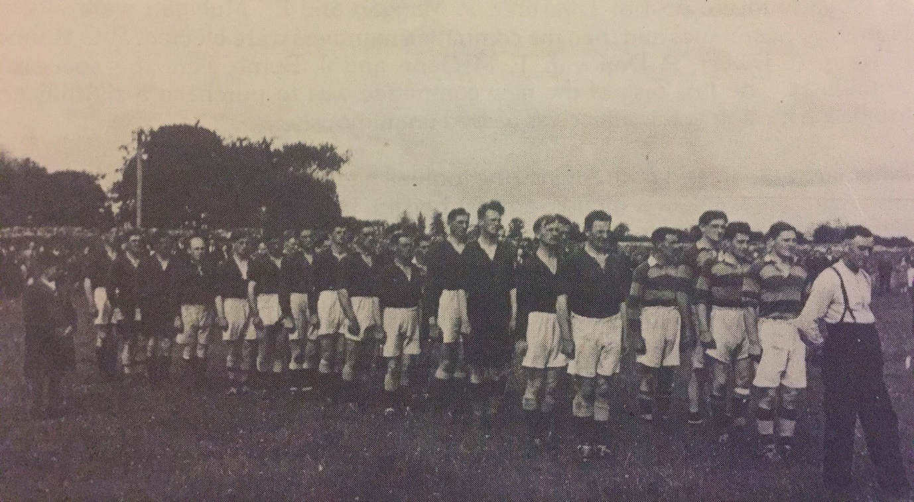

Paddy Healy – referee – far right in white shirt and braces

Mick Sammon was born on 7th February 1893 in Clane. In mid-1917 a branch of Sinn Féin was established in Kilcullen and Mick was elected vice-chairman. He was later elected an officer of the local Irish Volunteer branch in Kilcullen. On ‘Lady Day’, 15th August 1918, at an illegal after Mass meeting in Kilcullen, Mick Sammon read out the Sinn Fein manifesto. He was arrested two days later and was held in custody at the Curragh Camp prison until 20th September. He was court marshalled at Portlaoise (Maryborough) Barracks and sentenced to 1 month’s imprisonment which was spent firstly in Mountjoy Gaol, and then for a shorter period in Belfast prison. He lived in Celbridge from 1922 until his death, after a short illness, aged fifty-four on 24th April 1947 in Peamount Sanatorium. He is interred in the Franciscan Friary Cemetery, Clane

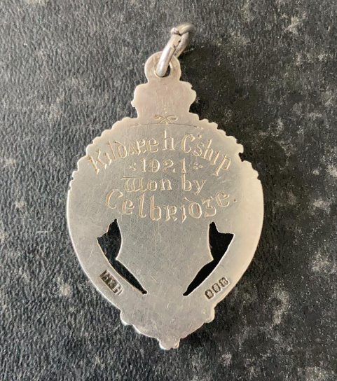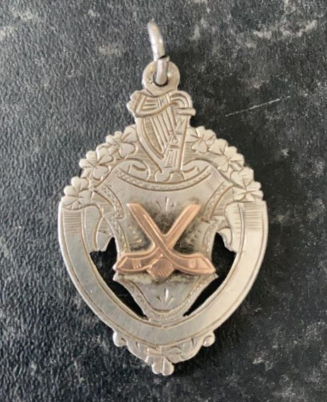

Both sides of George Magan’s 1921 SHC medal – courtesy of Dermot and Maeve Magan
The Match Report - 1921 Kildare Senior Hurling Championship Final
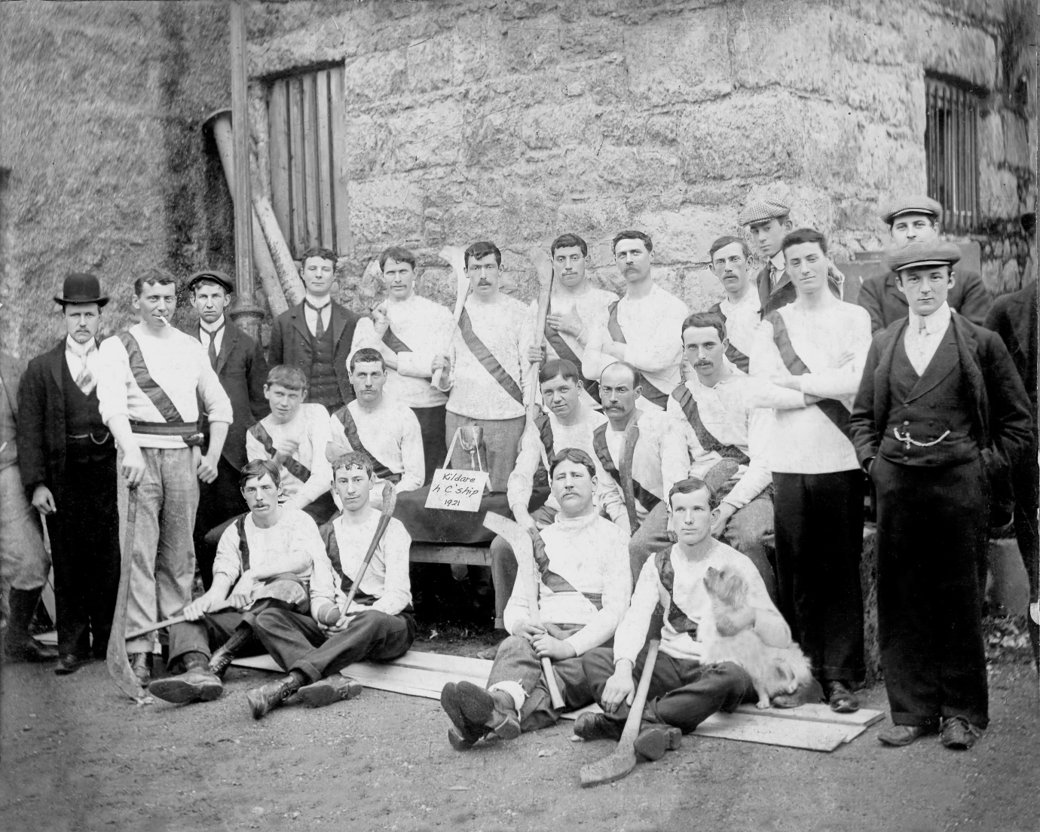

Celbridge - 1921 Kildare Senior Hurling Championship Winners – courtesy of the Murphy family

There simply is nothing more that can be added which would embellish the original match report as published by the Leinster Leader on the 5th May 1923. The Evening Herald of the same date also made brief mention of the match and its result.

“Hurling at Droichead Nua
The fact that the final of the hurling championship was arranged for Droichead Nua on Sunday last attracted a large number to the grounds of the Dominican College, and indeed all that were present followed with interest the play between Celbridge and St Conleiths throughout the game. The play opened at three o’clock with the Rev. Fr Fogarty O.P. as referee. Soon after opening Celbridge placed a goal to their credit and followed up soon after with a fine dash measuring a point. Joyce Conlan in the home posts had to beat back many an attack made by the boys from Cill Droichead, and very successfully for a time. Still although the defence was a good one and the clash of the camán was to be heard occasionally in a good fight, it was evident that the home team, although playing an admirable and plucky match had not the training in the art of the game to the same extent as their friends from the other picturesque Droichead Nua further up the Liffey. The close of the first portion of play found Celbridge leading with 3 goals 1 point to nil. After play had settled down after the change, Celbridge soon added a point and St Conleiths putting on a fine sprint also registered a point. There was a very good and fast match which was keenly enjoyed from this forward until the final whistle went, leaving the score – Cill Droichead (Celbridge), 4 goals 2 points; St Conleith’s 1 point.”

If there was a Man Of The Match award it would have gone to ‘Skipper’ Murphy - by all accounts he delivered an excellent performance. His own comment was that the success on the day was due to “the great team effort”.

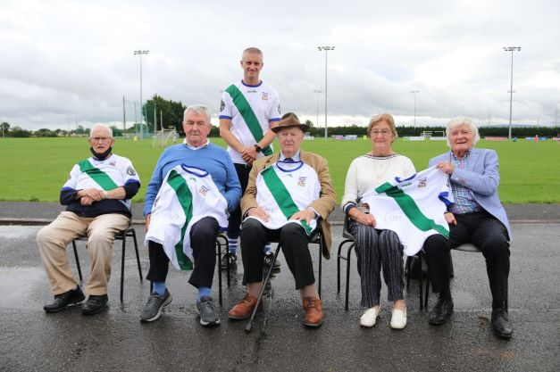

Presentation of commemorative 1921 jerseys to children of the players 21st August 2021 –
Sitting from left to right: Jimmy Healy (son of Paddy Healy and nephew of Albert O’Neill), Tommy Fay (son of Jim Fay), Pat Murphy (son of Owen ‘Skipper’ Murphy), Maeve and Dermot Magan (children of George Magan and niece and nephew of William Magan). Standing: Ciarán O’Donovan

The Legacy
The centenary of the 1921 championship may only now be upon us, but the memory of that win was kept alive and well within Celbridge throughout the years, and its effects still reverberate. Its impact was nowhere more evident than on 23rd September 2005 when Celbridge hurlers were attempting to win their first Kildare Senior Hurling Championship title since 1923.

Nobody associated with the 2005 team will ever forget the emotion and sense of history felt when, on the morning of the final, team manager Jimmy Doyle – himself a Celbridge hurler for many years, and his family steeped in Tipperary hurling lore - gathered the players in a circle on the Celbridge pitch, placed Owen ‘Skipper’ Murphy’s 1921 winner’s medal reverentially on the grass in the heart of the circle, and gave an electric, rousing, speech about what this opportunity meant, the history of the moment, the linkages with the past, and the possibilities for the future. That young Celbridge team travelled to St Conleth’s Park Newbridge and proceeded to beat the mighty Coill Dubh, who had dominated Kildare hurling since the late 1980’s, and claim only the club’s second Kildare SHC title - its first in 82 years. Since then a further six Kildare SHC crowns have been added to the Celbridge roll of honour bringing its Kildare SHC titles total to eight.

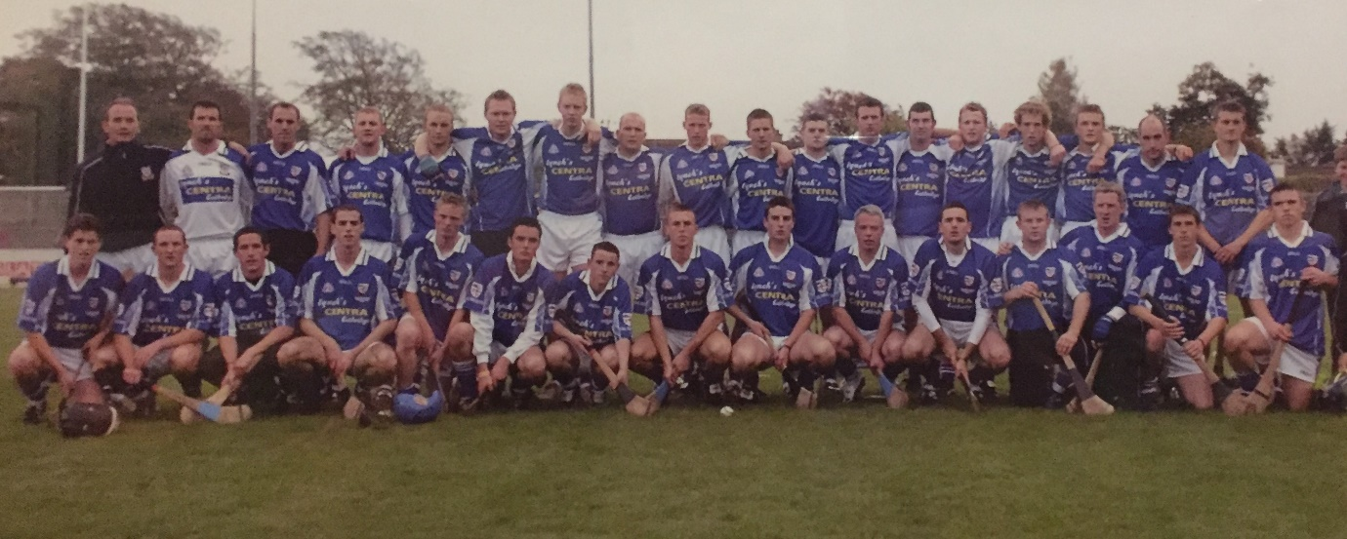

Celbridge – Kildare SHC winners 2005. The 82 year wait is over

There is a familial connection which links all eight Celbridge titles. Donal Moloney – captain of the 2005 and 2013 Celbridge winning teams - along with his brothers Mark and Patrick, all of whom played in the 2005 final and have won multiple Kildare hurling titles with Celbridge, are related through their grandfather Donal Magan to the Magan brothers, George and William. Like their cousin George, all the Moloney brothers represented Kildare on the hurling pitch, with Donal captaining Kildare in 2006, and Mark having a very distinguished career for the county for more than a decade, winning two Christy Ring Cup medals and two Christy Ring All-Star awards.
It is fitting that there still exists over the last 100 years that common thread running from the victorious 1921 championship team right through to the club’s second win in 2005, and continuing within all subsequent triumphs into the present day.

Hurling has had an inconsistent history within Kildare, and Celbridge was no exception, with the sport dying out in the club on a number of occasions only to be repeatedly reignited by the dedication and love for the game of many individuals. The great playing numbers and current success of juvenile and adult hurling within Celbridge, is a tribute to the many Gaels who persevered over the decades to keep hurling alive in the parish, and will no doubt continue to prosper into the future, along with the rising tide of Kildare hurling.

The heroes from the 1921 championship win may be gone, but they will never be forgotten.
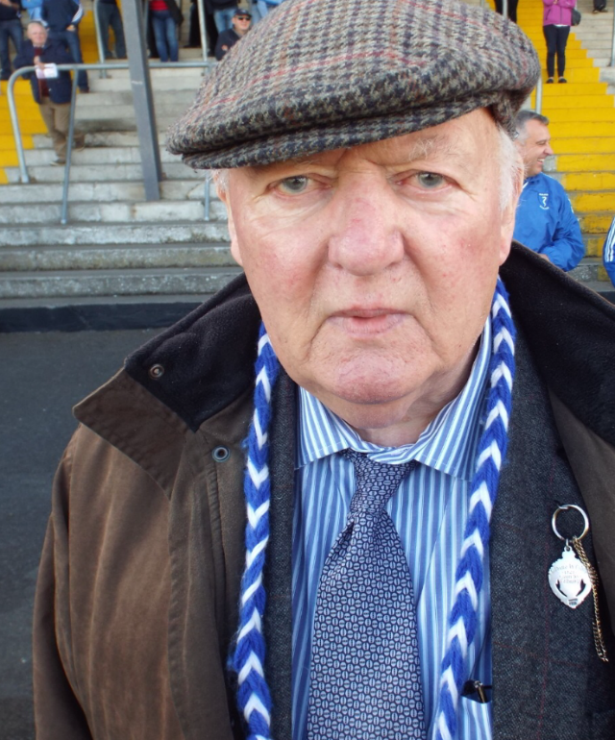

Pat Murphy wearing his father Owen’s 1921 medal the day Celbridge won the 2016 Kildare SHC final

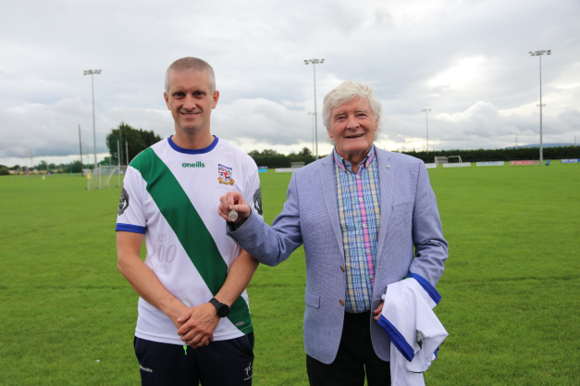

Dermot Magan presenting his father George’s 1921 medal to Celbridge GAA – gratefully accepted by Ciarán O’Donovan

References
Co. Kildare Online Electronic History Journal “The Kildare Team and Officials for the 1919 All-Ireland Final” 2019
Darragh Mac an tSaoir “Celbridge GAA History“, 1984
Dictionary of Irish Biography, Royal Irish Academy, Aaron O’Maonaigh, “Pádraig O’Conchubhair”
Drogheda Independent, 24th June 1924, p. 17
Eoghan Corry “Kildare GAA: A Centenary History", CLG Chill Dara, 1984
Eoghan Corry “Some Key Dates in Celbridge History”, Co. Kildare Online Electronic History Journal, 2009
Evening Herald, 5th May 1923, p. 2
Gaelic Echo, 16th Dec 1944, p. 5
James Durney “Stand you now, for Erin’s Cause. A biographical dictionary of Co. Kildare participants in the revolutionary period, 1913-23” (Publication date June 2022)
James Durney “Volunteer Thomas McEvoy’s activities in Kildare”, 2010
Kildare Observer, 5th July 1902, p. 7
Kildare Observer, 31st Jan 1920, p. 4
Kildare Observer, 11th Mar 1922, p. 4
Kildare Observer, 6th May 1922, p. 4
Leinster Leader, 5th May 1923, p. 2
Leinster Leader, 4th December 1954, p. 5
National Archives of Ireland, Census 1901 & 1911
Oglaigh na hEireann Military Archives, BMH.WS0850
Oglaigh na hEireann Military Archives, BMH.WS0932
Oglaigh na hEireann Military Archives, BMH.WS1155
Oglaigh na hEireann Military Archives, BMH.WS1715
Raymund M. Dowdall O.P., D.C.L., Archivum Ord. Praed. Prov. Hib. “Memories of still more Recent Irish Dominicans who passed away between the years 1950-1960”, 1968
Seamus Cullen “Mick Sammon - Kildare referee on Bloody Sunday”, 2020

Acknowledgements
- Special thanks to James Durney for all the Irish Volunteer / military backgrounds on players he generously provided, and his draft review
- Eoghan Corry for his advice and assistance
- Kevin Murphy, Local Studies Dept in Kildare Library Service, for all his help with online newspaper archive searches and provision of other relevant materials
- Particular thanks to Pat Murphy for the multiple conversations, and all the great memories and stories he recounted
- Thanks to Maeve and Dermot Magan for presenting their father’s 1921 medal to Celbridge GAA
- Thanks to Tommy Fay for re-telling his father’s stories
- Pat and Teresa Moloney for clarifying the family link to the Magan brothers
- Niall Lanigan for his encouragement and feedback, and of course for driving the 1921 commemorative jersey initiative
- Diarmaid O’Donovan for his draft reviews
- Fr. John Harris O.P., B.A., S.T.D. (Angelicum), Prior of the Dominican College Newbridge, for his assistance in helping to research Fr. Fogarty
- Brendan Holmes for all his time, help and advice

