Kildare
Coiste Chill Dara
St. Conleth`s Park
Newbridge
Co. Kildare

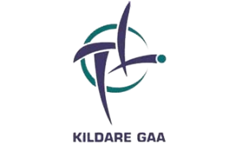

2021 EMS Copiers Senior Football League Division 4 Group A
Round 2 - 16-06-2021 (Wed)
Ardclough V Grangenolvin

Round 1 - 19-06-2021 (Sat) TBC
Grangenolvin V Rathcoffey
Athgarvan V Ardclough
Cappagh V Suncroft

Round 2 - 23-06-2021 (Wed) TBC
Rathcoffey V Cappagh
Suncroft V Athgarvan

Round 3 - 03-07-2021 (Sat)
Athgarvan V Cappagh
Suncroft V Grangenolvin
Ardclough V Rathcoffey

Round 4 - 07-07-2021 (Wed)
Rathcoffey V Suncroft
Grangenolvin V Athgarvan
Cappagh V Ardclough

Round 5 - 10-07-2021 (Sat)
Suncroft V Ardclough
Athgarvan V Rathcoffey
Cappagh V Grangenolvin

2021 EMS Copiers Senior Football League Division 4 Group B
Round 1 - 10-06-2021 (Thu)
Ballykelly V Castlemitchell
Kill V Robertstown

Round 1 - 13-06-2021 (Sun)
Kildangan V Ballykelly

Round 2 - 20-06-2021 (Sun)
Miltown V Kildangan

Back Matches - 30-06-2021 (Wed)
Robertstown V Miltown
Castlemitchell V Kill

Round 3 - 03-07-2021 (Sat)
Miltown V Kill
Robertstown V Ballykelly

Round 3 - 04-07-2021 (Sun)
Kildangan V Castlemitchell

Round 4 - 07-07-2021 (Wed)
Castlemitchell V Robertstown
Ballykelly V Miltown
Kill V Kildangan

Round 5 - 10-07-2021 (Sat)
Robertstown V Kildangan
Miltown V Castlemitchell
Kill V Ballykelly

